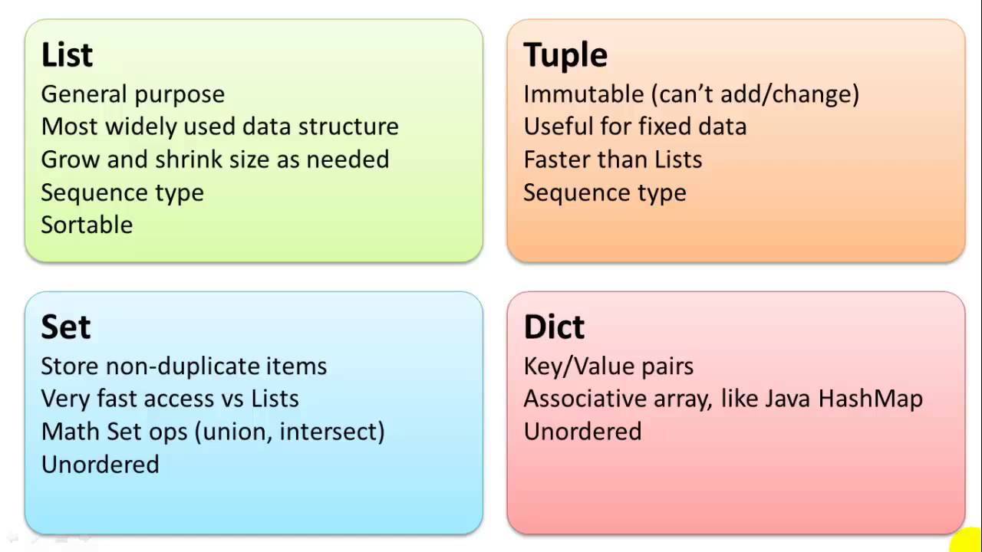

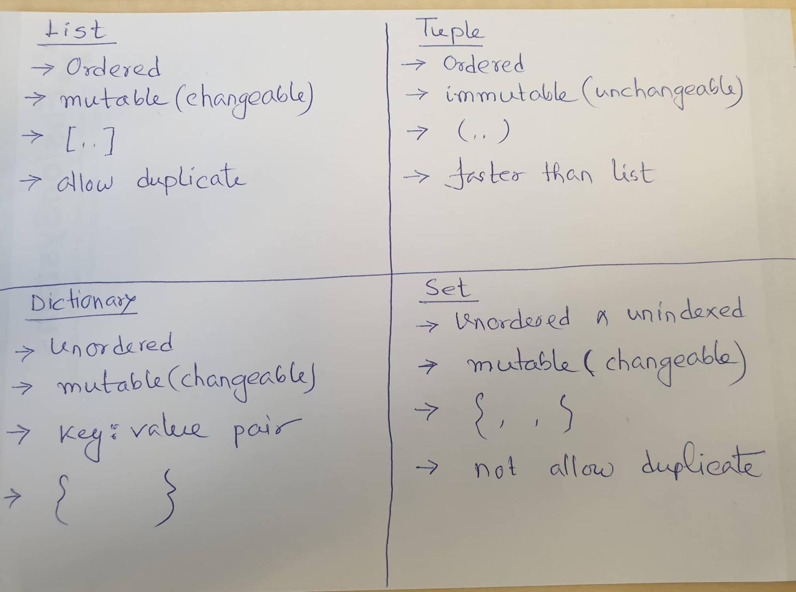

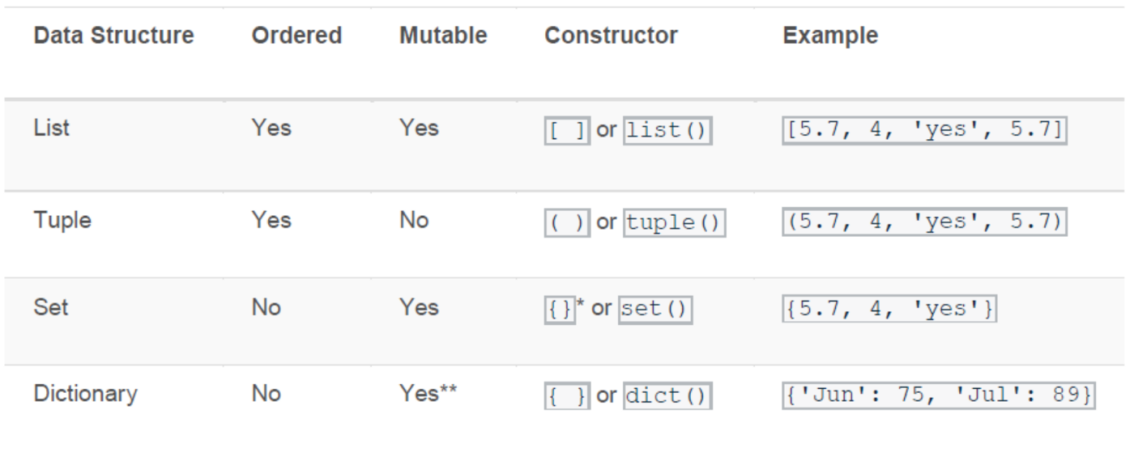

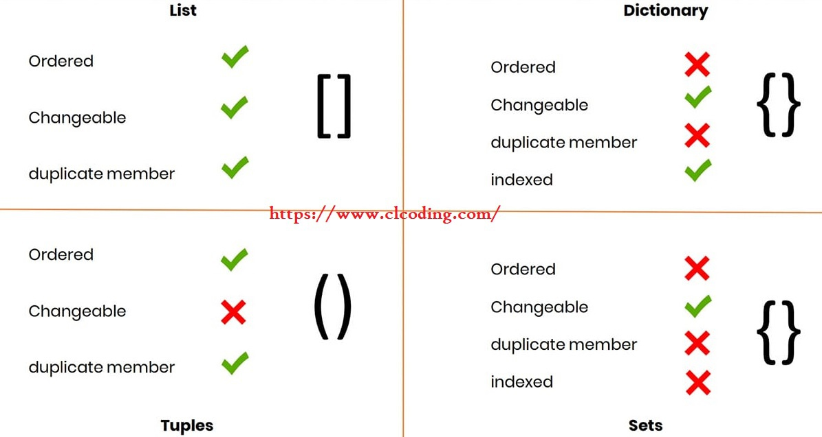

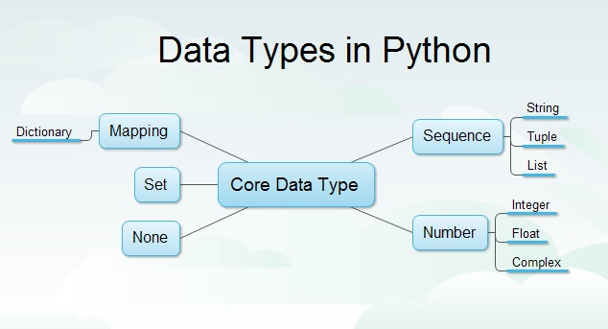

All of list, tuples, set and dictionary are iterable

All of them allows for…in… loop

*************************************************************************************

**Starting List**

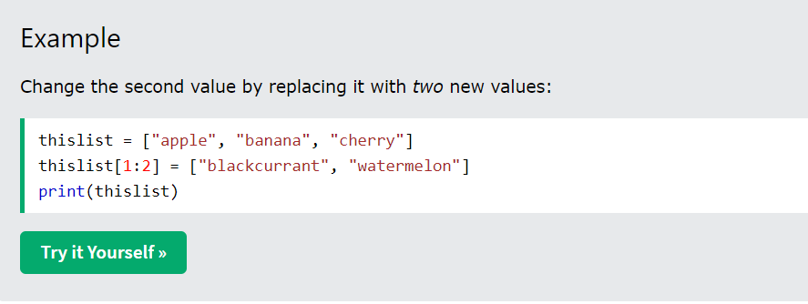

Same thing we did with strings

**.append( )**

This method appends new items at the end of list

**.pop ( )**

this method removes the last item of list and returns that removed item if not provided any index value

**.pop( index_value )**

Removes the item of the given index, and returns that item

**.remove( name_of_item )**

Removes the named item

**.insert( index_number, item_to_be_inserted )**

Inserts item at the designated index position

**.extend( any_iterable )**

Extends the given list by appending elements from the provided iterable

All list, tuples, set and dictionary are iterable

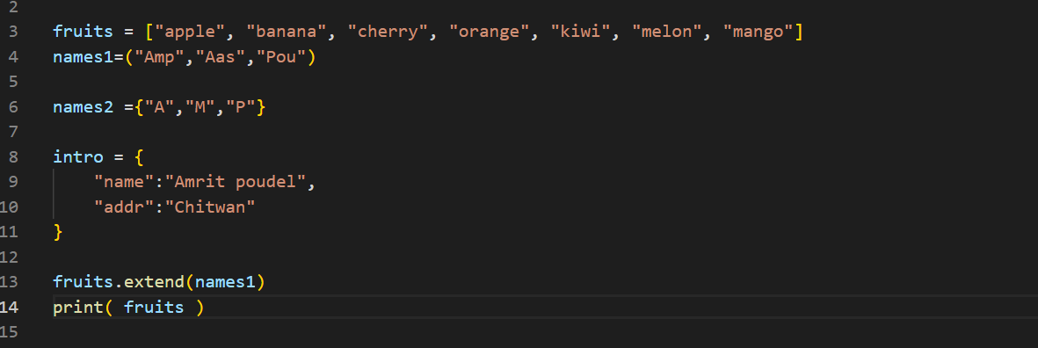

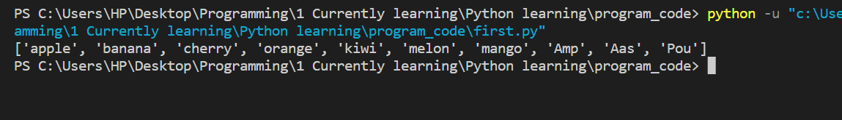

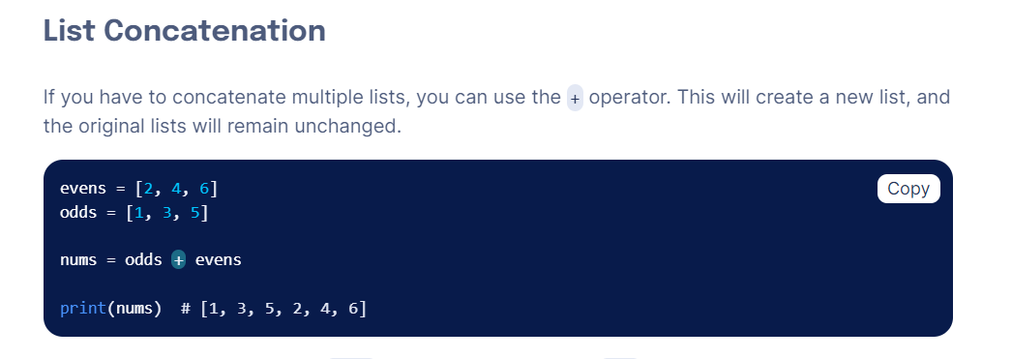

**del keyword**

it can delete the specified list item

it can also delete the whole list

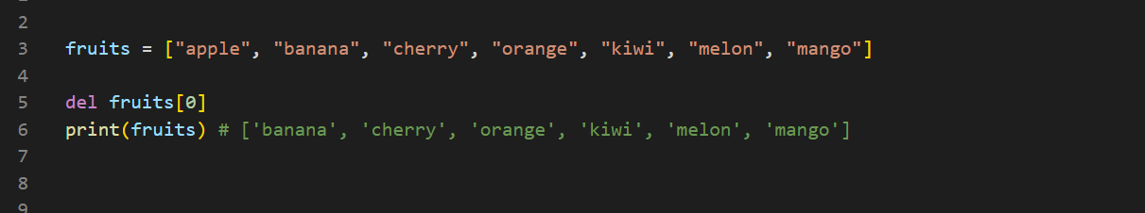

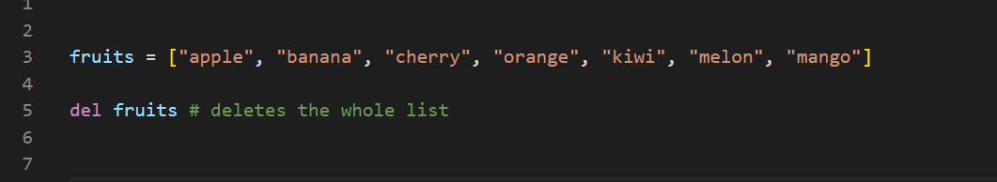

**.clear( )**

It clears the list

It empties the list

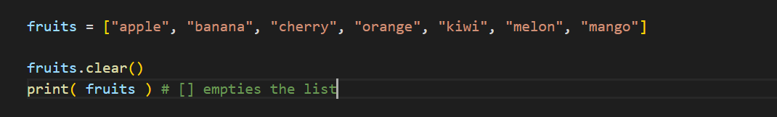

**List Comprehension**

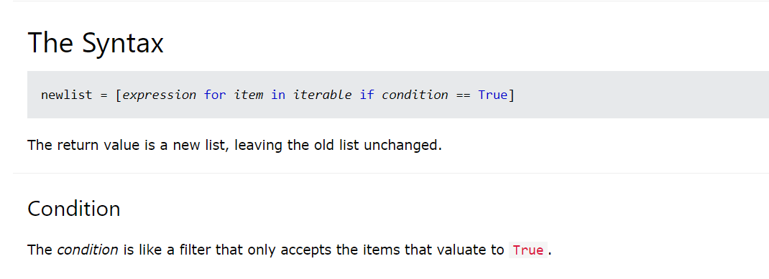

Using this we can get our desired list from the existing list

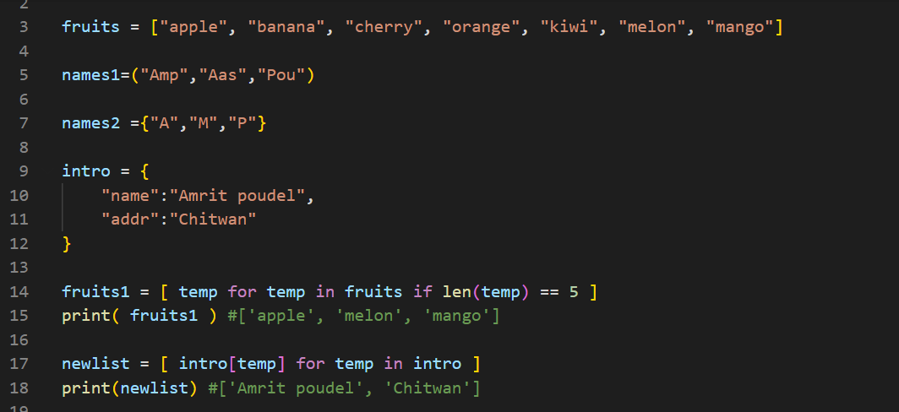

**This is super useful**

**Case1: Using condition before the for…in.. iteration**

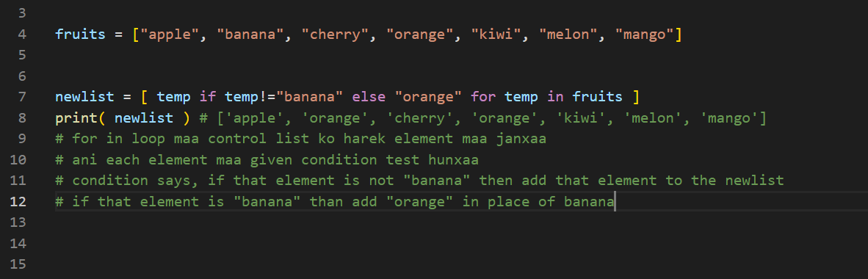

**Case2: Using condition after the for…in… iteration**

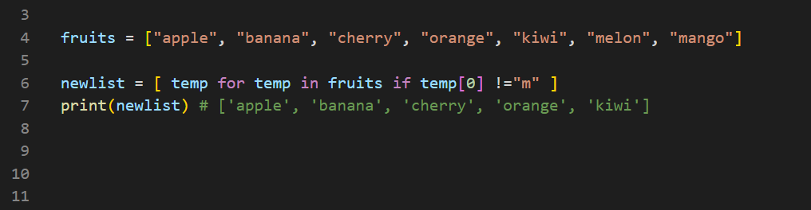

**Here we do not need to specify else condition**

We can drive different list from the given list based on our need

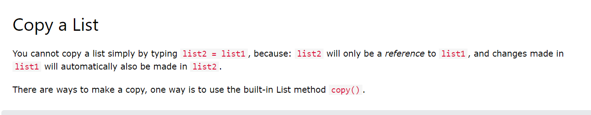

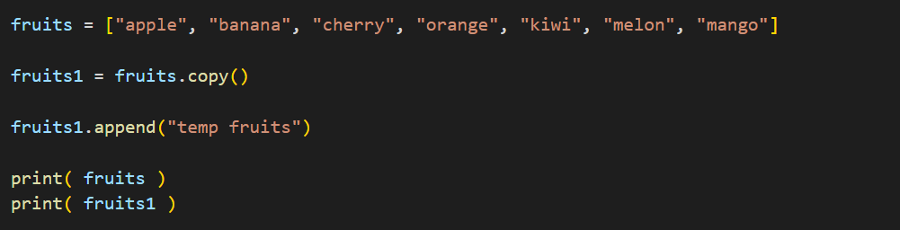

Sorting list in Ascending order

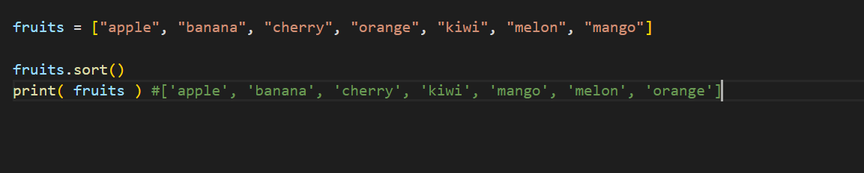

Sorting list in descending order

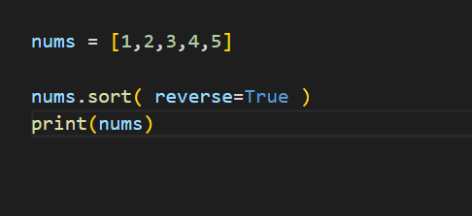

Reverse the list

